**CUSTOM MODULE**

* **The module helps to extend and customize Drupal functionality. Drupal have three kinds of modules, core, contributed and custom.**

Requirements:

Folder Structure:

1. Module_name.info.yml

**Module_name.info.yml** file contains the meta information of your module and it is required for your module. Missing of this file your module will not appear in the module listing.

1. Module_name.routing.yml

Module_name.routing.yml route can be defined as a path where we return some content. A routing file contains the path by which our module can be accessed. A route path can also be called a path alias. Using the path alias defined in the routing file we can execute the callback function.

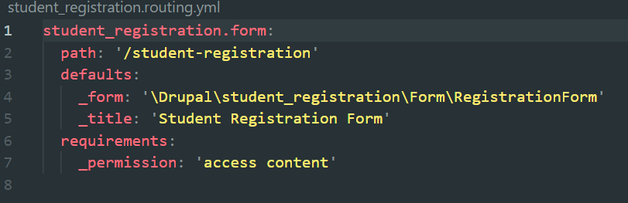

1. Php file

Php code, to create a form, you need to extend “FormBase” core class and an interface

use Drupal\Core\Form\FormBase;  
use Drupal\Core\Form\FormStateInterface;

When you use ***FormStateInterface,***you should use the following functions as well **getFormId(), buildForm() and submitForm()** without these function a form cannot be created.

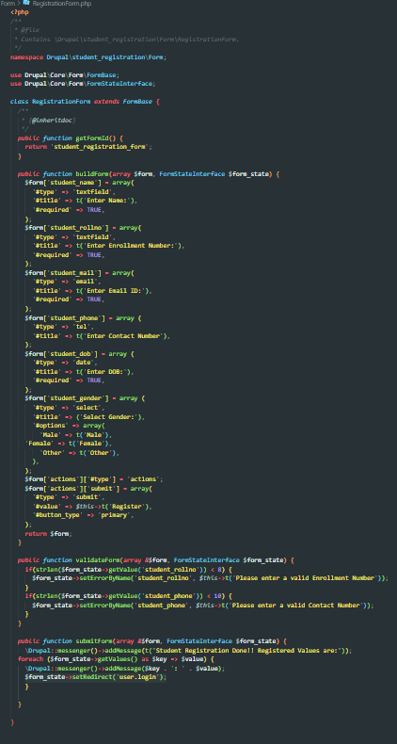

getFormId() – this is where you have to mention your form id and it should be unique  
buildForm() – this is where you will create your form  
validateForm() – here you can write your form validations  
submitForm() – this is where you can handle submit processes

Now you have your custom module and a custom Form created, as we have already enabled the module just clear cache and access the path https://localhost/drupal**/myform** to see your custom form

1. Enabling our custom module



#### Visit the path we have defined in the routing file to access our form. Here it shall be “/student-registration”.

#### A screenshot of a computer

#### After submitting the form we can view the result as a message.

